E-Government and Digital Participation in Aceh: Public Perceptions of Digital Service Applications

Said Amirulkamar^{1*}, Safirussalim², Khalida Ulfa¹, Ghina Nabilah Effendi³

¹ State Administration Science, Faculty of Social and Governmental Sciences,
UIN Ar-Raniry, Aceh, Indonesia,

² Management Economics, Faculty of Economics and Business, Syiah Kuala

³ State Islamic University of Sultan Thaha Saifuddin Jambi, Indonesia
e-mail: said.amirulkamar@ar-raniry.ac.id

Abstract

This study analyzes the perceptions of the people of Aceh regarding digital public service applications within the framework of e-government in Indonesia, focusing on the aspects of convenience, trust, and participation. Using the Technology Acceptance Model (TAM) and qualitative analysis with NVivo 12 Plus, the results show uneven utilization of services, with services such as e-JKN and Samsat Online being considered practical and useful, while some online services are still less than optimal. Structural barriers in the form of infrastructure limitations, low digital literacy, suboptimal application quality, and weak policy dissemination reduce public participation. Nevertheless, digital public services in Aceh show positive potential in improving efficiency and convenience. To build inclusive and sustainable digital services, it is necessary to improve infrastructure, simplify application design, expand digital literacy, and increase service transparency and consistency.
Keywords: Aceh, digital, services, e-government.

INTRODUCTION

Accelerating bureaucratic transformation through digital-based public services is a strategic program of the Indonesian government, as mandated by Law No. 95 of 2018 concerning the Electronic-Based Government System (SPBE) and reinforced by Presidential Regulation No. 82 of 2023 on the acceleration and integration of national digital services [1]. The main objective is to improve efficiency, transparency, and public participation through digital governance, which requires close cooperation between the government and the community as the primary users of public services.
Globally, digital-based bureaucratic transformation has become a key agenda in modern governance. The United Nations E-Government Development Index (EGDI) highlights that many countries adopt digital technologies to enhance service delivery, efficiency, and accountability. Indonesia, as a developing country, follows this trend by implementing e-government initiatives as part of its effort to improve public service quality and inclusiveness.
However, the implementation of e-government in Indonesia still faces major challenges. Digital infrastructure gaps, limited technological literacy, and low awareness of application-based services hinder the effective use of digital platforms. These challenges are even more complex in regions with unique socio-cultural and regulatory contexts, such as Aceh, which has special autonomy and governance influenced by its local wisdom, namely Islamic law. This context requires adaptive strategies to ensure inclusiveness and responsiveness in the delivery of digital public services.
In Aceh, several digital public services, such as the online e-KTP (electronic ID card), the online Samsat (Sat Online), and a population application, have begun to be implemented. However, the reality on the ground shows that the utilization rate of these digital applications remains low. Barriers such as limited internet connection, frequent server outages, low digital literacy, and a lack of outreach are factors that limit public participation in accessing services. This is reflected in the regional SPBE index, which continues to fluctuate and has not yet reached the optimal category.
The gap between government efforts to provide digital public services and low public participation is a critical issue that requires further investigation. Public perception of the quality, ease of use, and usefulness of public service applications will significantly determine the success of e-Government implementation. Therefore, an in-depth analysis of the experiences and challenges of Acehnese people in using digital public services is relevant not only for improving services at the local level but also as a learning experience for strengthening digital bureaucratic transformation in Indonesia in general.
E-government, or electronic-based government, has its own objectives, including utilizing technology to deliver and receive information digitally, ensuring efficient and reliable public access. Accelerating digital public services prioritizes integrity and transparency, in accordance with the principles of good public service delivery [2].
According to Fred D. Davis (1986), through the Technology Acceptance Model (TAM), public acceptance of technology is determined by two main factors: Perceived Usefulness (perceived benefits) and Perceived Ease of Use (ease of use) [3]. In the context of digital public services, Acehnese people will be encouraged to use service applications if they perceive tangible benefits, such as time efficiency in processing population documents or obtaining business permits. Furthermore, public service applications must be easily accessible and operational, so as not to pose obstacles for users with diverse digital literacy levels. Therefore, the success of digital-based bureaucratic transformation is determined not only by government policy, but also by the extent to which the technology presented is perceived as useful and easy to use by the public. The integration of TAM theory in this study indicates that technology adoption in digital public services will increase if public perceptions of the benefits and ease of use of the applications can be optimally met.
Aceh Province faces two challenges in developing digital governance due to its special autonomy and Islamic law. On the one hand, the local government must adopt national innovations in digitizing public administration. However, sociocultural characteristics and gaps in ICT infrastructure raise doubts about the level of Acehnese participation in digital utilization and their engagement with digital public service applications. offered.
Digital public services have also shown increased public participation, although not yet optimal, as some users still prefer manual services. The government's initiative to integrate various services through a single digital portal is still being refined.

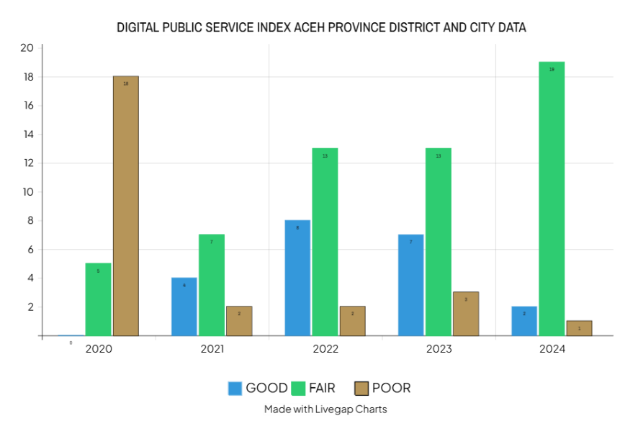

Figure 1. Digital Public Service Index Aceh Province District And City Data, (Processed By Researchers, 2025)

(Source: 2020-2024 Annual Report SPBE, PANRB)

The graph above illustrates the uneven distribution of digital public services in Aceh Province. Over the past four years, implementation has tended to be suboptimal. This indicates that the quality, accessibility, and utilization of digital services such as e-passports, online Samsat (Sat Online), and e-JKN (National Health Insurance) still vary across districts/cities. Several regions have consistently achieved high levels of digital public service, as evidenced by their highest scores in the city category, while others lag far behind with low scores. This disparity indicates the need for strategies to equitably distribute digital infrastructure, improve public technological literacy, and strengthen coordination between agencies to ensure equitable digital participation across Aceh.
Although the digitalization of public services has become a national agenda, the level of digital application utilization in Aceh remains low. Most previous research has focused on institutional aspects, regulations, and government infrastructure readiness for e-Government implementation. Meanwhile, studies that position the public as users are still limited, particularly in the context of a special autonomous region like Aceh, which has distinct socio-cultural characteristics and infrastructure compared to other regions in Indonesia. This gap is the focus of this research.
The focus and objective of this research is to analyze the perceptions of the Acehnese public regarding the use of digital public service applications as a form of e-government implementation, with an emphasis on the level of ease, trust, and digital participation of the public. This study aims to determine the extent to which the public accepts, utilizes, and engages in digital government services and to identify the obstacles faced in order to provide recommendations for improving services to be more inclusive and responsive.
This research addresses the gap between government efforts to digitalize public services and the relatively low utilization by the Acehnese public. By examining perceptions of usefulness, ease of use, and trust, it highlights both the barriers and the opportunities for building more inclusive and sustainable digital governance in Aceh.

METHOD
This study employs a descriptive qualitative approach to explore Acehnese people's perceptions of digital public services provided by the local government and related agencies. The approach was chosen to understand experiences, perspectives, and factors influencing community digital participation in context.

Data Collection
Primary data were obtained through Google Forms and focus group discussions, involving three categories of respondents: (1) active users of digital public services, (2) passive users, and (3) non-users. Secondary data were gathered from policy documents, statistical reports, and official government publications regarding e-government in Aceh.

Data Analysis
Data were processed using NVivo 12 Plus, applying open, axial, and selective coding to identify themes, subthemes, and relational patterns. Responses from Google Forms were first visualized, then analyzed with NVivo coding techniques. The coded results were further examined using the Crosstab Query feature to compare the distribution of themes across demographic indicators, allowing researchers to assess the relationship between these factors and levels of digital service usage. The data analysis process was conducted using NVivo 12 Plus using coding techniques to identify themes, subthemes, and patterns of relationships between variables. The Google Form data was visualized using NVivo 12 Plus analysis, then imported into NVivo for open, axial, and selective coding [4]. The coding results were then analyzed using the Crosstab Query feature to compare the distribution of themes based on indicators used in the study, relating to the focus and objectives of the study, and the level of digital service usage. This approach allows researchers to see the relationship between demographic factors and perceptions and levels of digital participation.

Related to the TAM Framework
To strengthen the interpretation, findings were categorized according to the Technology Acceptance Model (TAM) constructs [3]:
- Perceived Ease of Use – Indicators such as service speed, accessibility, and ease of application highlighted usability differences. While frequency of use was highest, service diversity remained limited, indicating restricted breadth of engagement.
- Perceived Usefulness – Participants emphasized accuracy of results, transparency of procedures, and availability of services as determinants of continued use.
- Trust and Participation – Levels of trust in digital public services influenced digital participation, literacy, and willingness to engage with e-government platforms.

Implications
Although the study focused on Aceh, the findings reflect broader challenges in digital governance, particularly in regions with uneven infrastructure and varying levels of digital literacy.

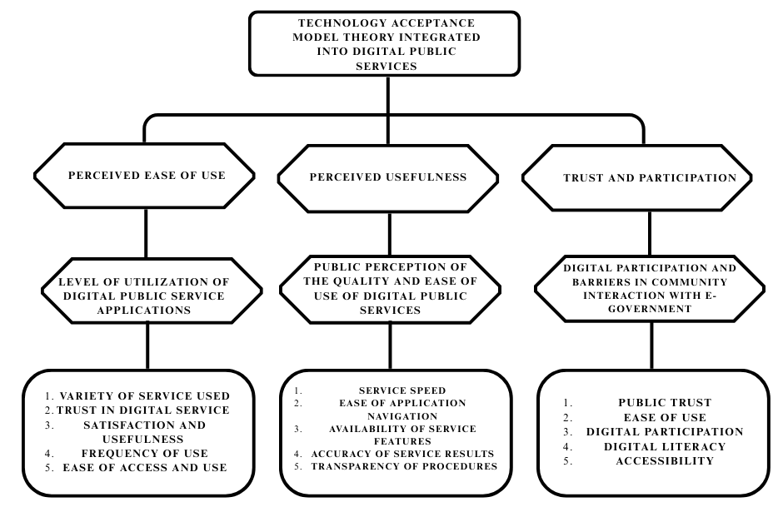

Figure 2. Theoretical Framework, 2025.

RESULTS AND DISCUSSION

Level of utilization of digital public service applications by the Acehnese people (Perceived Ease of Use)

Applications in digital services for the public in today's era have become a necessity, considering the efficiency of time and costs.
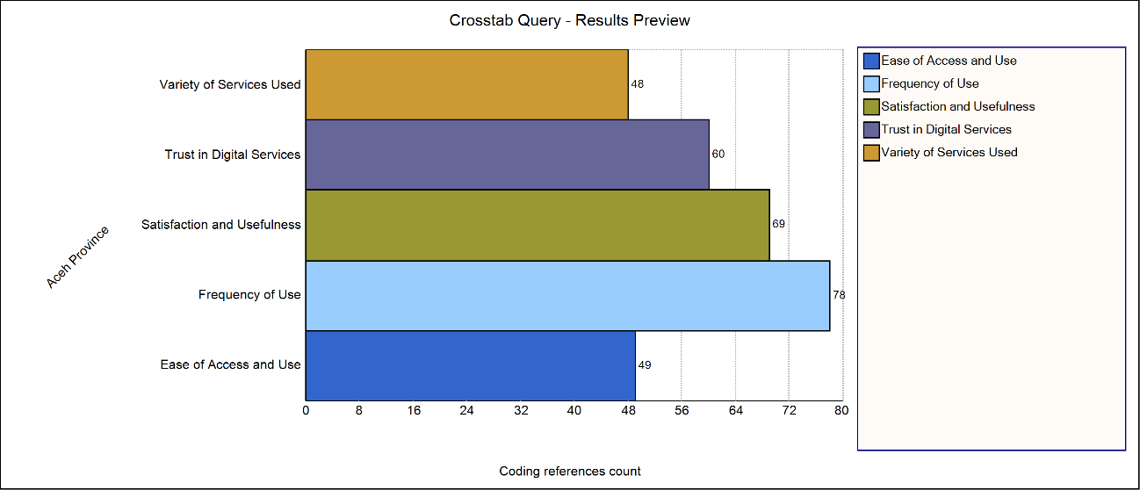

Figure 3. Utilization Level Indicator (processed by researchers, 2025).

This graph displays the results of a Crosstab Query analysis using NVivo 12 Plus, which measures five key indicators of the level of public digital public service application utilization in Aceh Province. Each indicator is represented by a horizontal bar indicating the number of coding references or the number of occurrences of the related theme in the qualitative data. The first indicator is Ease of Access and Use, which has a value of 49 coding references. This indicates that ease of access and ease of application operation are factors frequently mentioned by respondents, but not in the highest position. This means that while ease of access is important, other factors are more dominant.
The second indicator is Frequency of Use, or the frequency of use of digital public service applications. Its score reached 78, which is the highest among all indicators. This indicates that respondents most frequently mentioned how often they use the applications. This high score indicates that frequency of use is the aspect that most strongly reflects the level of digital application utilization in Aceh. The third indicator is Satisfaction and Usefulness, or satisfaction and usefulness. With a score of 69, this indicator ranks second-highest. This indicates that the majority of respondents believe digital public service applications provide real and satisfying benefits in terms of convenience, efficiency, and time or cost savings. The fourth indicator is Trust in Digital Services, or the level of trust in digital services, with a score of 60. This figure is relatively high, indicating that many respondents feel confident in the data security, system reliability, and transparency of existing digital public services. This trust is important as social capital for the sustainable use of digital applications.
The fifth indicator is Variety of Services Used, with a score of 48. This is the lowest of all indicators. This means that although people use digital applications, the variety of services they utilize is not very diverse. This could be because some services are not fully integrated or do not meet user needs. Overall, this graph indicates that frequency of use and satisfaction/usefulness are the main drivers of digital public service application utilization in Aceh. This means that the more frequently people use an application and feel satisfied, the higher the level of utilization.
In contrast, indicators such as Variety of Services Used and Ease of Access and Use have lower scores, indicating room for improvement. For example, the government could expand the scope of services within a single application and simplify the interface and usage procedures. Trust in digital services is also an interesting finding, as although its score is not as high as frequency or satisfaction, it is still significant. This suggests a correlation between trust and continued use. If trust declines, the frequency of use may also decline. Overall, this graph illustrates that the Acehnese public has begun to actively utilize digital public service applications, with a primary focus on regular use and positive experiences with the services. However, to increase overall utilization, a strategy is needed to increase service variety and simplify access, while continuing to maintain user trust.

Public perception of the quality and ease of use of digital public services (Perceived Usefulness)
The pros and cons of digital public services serve as a benchmark for the realization of e-government. The digital transformation of public services in Aceh is a crucial aspect of the government's plan to improve the quality of public services. Since national policy encouraged the development of an electronic-based government system (SPBE), local governments in Aceh have begun adapting by adopting digital services aimed at increasing efficiency, transparency, and accessibility. However, this process is not without diverse public opinion, which serves as an indicator of the success or failure of e-government implementation.[5]For some people, the presence of digital public services is seen as an innovation that simplifies daily life. Services such as resident registration, permits, and public complaints can now be accessed without having to queue for hours at government offices. This convenience not only saves time but also minimizes transportation costs typically borne by citizens. This demonstrates that digitalization can increase service effectiveness while meeting public demand for fast and convenient services.
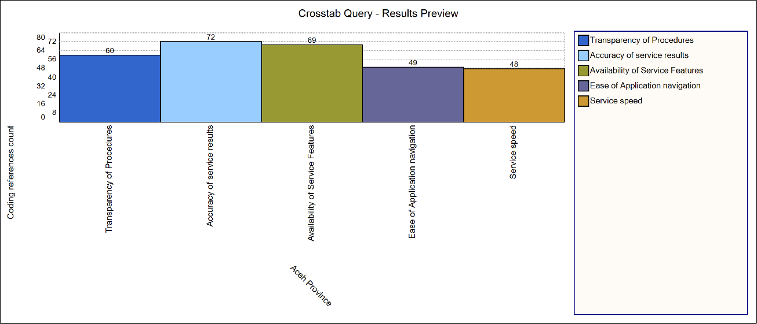

Figure 4. Public perception of the quality and ease of use of digital public services (processed by researchers, 2025).
Based on the results of the Crosstab Query graphic analysis above on digital public services in Aceh Province, it can be seen that public perception of service quality varies across indicators. The aspect with the highest score is the accuracy of service results, reaching 72, indicating that the public has a high level of trust in the accuracy of the output of the digital services provided. Furthermore, the service feature availability indicator also obtained a fairly high score, namely 69, indicating that most community needs have been facilitated through the features available in the digital public service application. Meanwhile, the procedural transparency indicator obtained a score of 60, which is in the medium category. This shows that although digital service procedures have been formulated quite clearly, there is still room for improvement in terms of information delivery to make it more easily understood by the wider public.
In contrast, the other two indicators showed significant weaknesses. The app's ease of navigation only scored 49, indicating that some users still experience challenges using the app, both in terms of appearance, menu flow, and technical complexity. In fact, the service speed aspect was the indicator with the lowest score, at 48, indicating technical issues such as system slowness, server limitations, or suboptimal network factors. Overall, these findings show that digital public services in Aceh have key strengths in the accuracy of results and comprehensive features, but still face significant challenges in user experience, particularly in aspects of service speed and ease of navigation. Therefore, technical improvements and improving the quality of application design are important priorities so that digital public services can be more effective, efficient, and inclusive in supporting digital-based bureaucratic transformation.
In this case, public perception will vary; some people still doubt the quality and reliability of the digital public service system provided by the government. Complaints include disruptions to digital public service systems, difficulties accessing frequently slow websites, and applications that lack user-friendly interfaces. These obstacles lead some people to opt for in-person visits even though online services are readily available. This demonstrates that technical quality plays a significant role in shaping public perception.
Research conducted in Aceh Province, for example, showed that usability significantly influences public trust in using e-government services. People who experience tangible benefits from digital services tend to trust and are willing to continue using the platform. Conversely, if perceived benefits are minimal, trust is low. This demonstrates that public trust is closely linked to their direct experience interacting with digital government systems.
The Aceh government continues to push for accelerated programs to equalize and accelerate internet access. There are 149 villages in Aceh that still experience blackouts or a lack of signal access. This has significant impacts, particularly on digital public services, health, education, and the economy. In today's modern era, internet networks have become a critical infrastructure in the digital era. The Head of the Aceh Communications and Information Office emphasized the importance of central government intervention to expand network coverage, especially in remote areas, given that e-government implementation is also intended for all districts/cities, including remote villages [6].
Information transparency also significantly impacts public perception. Financial reports, city profile data, and other public information displayed through official portals are considered to enhance government accountability. However, some citizens believe the information provided is often inaccurate or rarely updated. These shortcomings undermine public confidence in the credibility of digital services and create the impression that the government is not yet fully committed to leveraging technology for transparency. In several districts, technical barriers remain a significant issue. For example, in South Aceh, digital-based services at the population office are hampered by inadequate servers and networks. The available hardware frequently breaks down, preventing optimal service delivery. This is despite the local government's efforts to provide infrastructure and an internet network [7]. The problem is, the quality of the devices is not yet sufficient, so people still have to be patient with these limitations.
A similar situation was also found in Southwest Aceh. The public complaints platform SP4N LAPOR has not been fully utilized by the public or relevant agencies. Factors contributing to this low utilization include minimal public awareness, an unattractive website design, limited human resources, and a limited budget. Yet, the platform's existence is crucial as a two-way communication channel between the public and the government. Public perception of this service tends to be less than positive because their expectations have not been fully met [8].
In contrast, Banda Aceh City attempted to integrate various public services into a single platform called the Public Service Mall (MPP). This concept was praised as an innovation that centralized the delivery of various services, supported by a digital system. Residents using the MPP experienced convenience, as they could simply visit one location or access services online without having to travel between agencies. In terms of service quality, this positively impacted the city government.
However, despite its innovation, the MPP also faces significant challenges. Many people still don't fully understand the benefits of this service due to limited public awareness. As a result, many still prefer visiting government offices in person rather than trying digital services through the MPP. This demonstrates that, in addition to infrastructure, intensive public communication is essential to build public trust and familiarity with digital services.
In Aceh Besar, similar efforts are underway, although facilities are not as comprehensive as those in Banda Aceh. Evaluations show that the public has responded positively to the MPP, but their understanding of how to use digital services remains low. A lack of digital literacy makes it difficult for some to access online services. This situation emphasizes that the success of e-Government depends not only on technology but also on the readiness of human resources, both civil servants and users.
Meanwhile, in Simeulu, the digitalization process for the government remains slow. Many administrative tasks are still performed manually and do not yet fully rely on technology. Public perception of digital services in this region tends to be skeptical because they have not yet seen concrete evidence that technology can truly replace traditional methods. Comparisons with other regions show that gaps in infrastructure and human resource readiness significantly influence the differing adoption rates of digital public services [9]. Despite this, the public's positive perception of digital services remains, particularly regarding the aspect of convenience [10]. Citizens accustomed to using applications perceive digital services as reducing procedural complexity. This aligns with the goal of e-Government, which aims to reduce bureaucratic red tape and provide simpler access to services. In many cases, this positive perception stems from the government's successful development of a truly user-friendly system.
Conversely, when the system doesn't run smoothly, public complaints will intensify. Many citizens become frustrated when the system is inaccessible or when the application suddenly stops working. This creates a negative perception that digital services only complicate the process compared to manual methods [11]. Therefore, technical quality is a crucial aspect in determining whether the public perceives digital public services as a convenience or a burden. Beyond technical factors, the availability of digital services is often viewed in terms of fairness of access. Urban communities may find services easier to access due to stable internet connections, but in rural or remote areas, network limitations make digital services difficult to access [12]. This inequality gives rise to the perception that e-Government is not fully inclusive, because not all citizens have equal opportunities to access services.
From a government perspective, e-Government implementation is acknowledged to face numerous challenges. Civil servants still need to improve their capacity to effectively operate digital systems. Furthermore, limited budgets often hinder the ability to upgrade equipment or improve network quality. All of this impacts public satisfaction and ultimately influences their perception of service quality. Despite these challenges, the general trend shows increasing public satisfaction as more digital services become available. For example, online population administration services allow citizens to print documents without having to wait long. These positive experiences reinforce the perception that digital services provide real added value to the public.
However, public satisfaction is not the ultimate goal. Building long-term trust is more important. Trust arises when the public perceives the system to consistently deliver benefits, be safe to use, and be transparent in data management. If these factors are maintained, public perception will tend to be positive, even if there are occasional technical issues. Public perception of digital services is ultimately influenced by the balance between perceived benefits and perceived barriers [5]. This process is dynamic because over time, system quality can be improved, outreach can be expanded, and public digital literacy can be enhanced. When these three factors work together, public perception will become more positive.
Overall, the pros and cons of using digital public services in Aceh reflect the transition to mature e-government. Pros are evident in satisfaction with convenience, efficiency, and transparency. Contrasts, on the other hand, stem from technical constraints, limited infrastructure, and low public understanding. Both aspects are important because they provide input for the government in refining its public service digitalization policy. It can be concluded that Acehnese perceptions of the quality and ease of digital public services are still varied, but tend to be positive. These challenges are part of a collaborative learning process between the government and the public. If the government consistently improves infrastructure, enhances service quality, and strengthens digital literacy, e-Government in Aceh has the potential to become a successful model for realizing modern, effective, and inclusive public services.

Digital participation and barriers in public interaction with E-Government (Trust and Participation)
The government and the public are key players in the delivery of digital-based public services, as they mutually depend on each other and require effective collaboration. However, implementation remains suboptimal. Among others, such as the analysis results below.
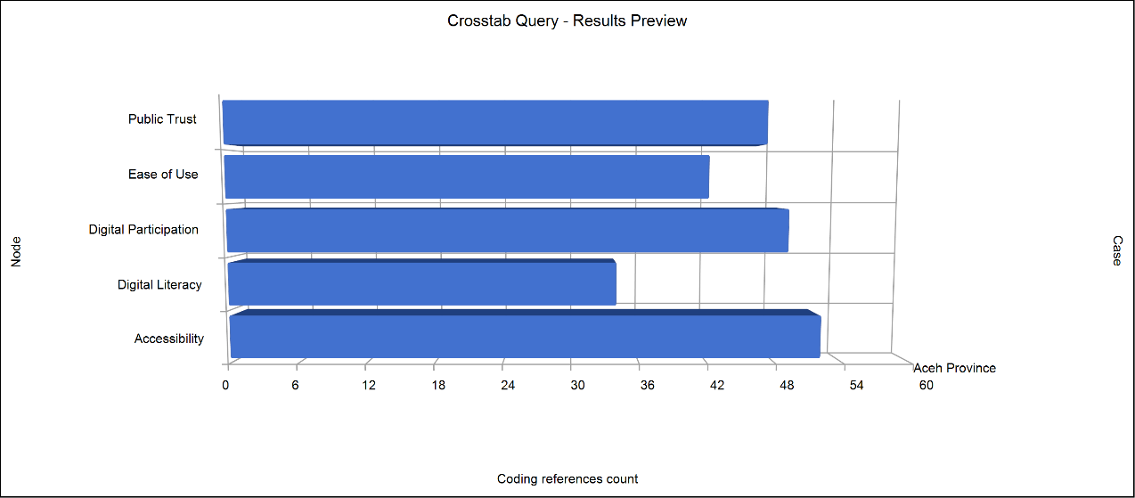

Figure 5. Digital Public Service Index Aceh Province (processed by researchers, 2025).

The Crosstab Query graph displayed illustrates the distribution of coding references across five main categories related to Acehnese public interactions with digital public services. These categories are Accessibility, Digital Participation, Public Trust, Ease of Use, and Digital Literacy. This data reflects the intensity of discussion or the emergence of these themes in interviews, surveys, and qualitative analyses conducted with respondents in Aceh Province. In the context of digital participation, the Accessibility indicator ranks highest, accounting for approximately 50 percent.
This high figure indicates that service affordability, in terms of devices, internet networks, and platform availability, is the most frequently encountered issue. This confirms that Acehnese people view ease of access as a fundamental requirement for effective digital participation. The Digital Participation indicator ranks second with a reference count of around 48 percent. This figure indicates that public engagement in using and interacting with e-government services is already quite high. However, the narrow gap between Accessibility and Digital Participation indicates that when access is available, public participation levels can increase significantly, thus establishing a close relationship between the two. The Public Trust category ranks third with a reference count of around 47 percent. Public trust in e-government services is a determining factor in digital participation.
This high level of trust can be interpreted as valuable social capital for local governments to expand the adoption of digital services. However, if this trust declines, public digital participation could potentially be hampered. Ease of Use was recorded at around 42 percent. This figure indicates that although the majority of users consider digital services relatively easy to use, some still feel the interface design or usage flow is not entirely user-friendly. This can be a barrier to participation, especially for new users or those less familiar with technology. Digital Literacy ranked lowest with a reference number of around 34 percent. This low figure confirms that the public's ability to understand, operate, and utilize digital services remains a serious barrier. Low digital literacy can limit participation, even when accessibility and ease of use are adequate.
Of the five categories, the three most relevant to describing digital participation and barriers are Digital Participation, Accessibility, and Digital Literacy. Accessibility serves as the gateway, Digital Literacy as the ability to utilize, and Digital Participation as the concrete form of involvement. All three are interrelated and determine the success of e-government implementation in Aceh. The nearly equal correlation between high Accessibility and Digital Participation indicates that when technical and infrastructure barriers are overcome, public participation increases significantly. Conversely, if Digital Literacy is not improved, the use of digital services will be limited to certain groups of people who are already familiar with technology.
The presence of Public Trust and Ease of Use in the middle positions of the graph shows that while they aren't the primary barriers, they are still important supporting factors. Public trust ensures people feel safe using digital services, while ease of use ensures the interaction process doesn't lead to frustration or confusion [13]. Overall, this graph confirms that to increase digital participation in Aceh, the government needs to focus on improving accessibility, expanding internet and device coverage, and conducting digital literacy training. Public trust and ease of use must be continuously maintained and improved to ensure optimal and sustainable public interaction with e-government.
The graph shows that Accessibility ranks highest with around 50 percent, indicating that the availability of access to devices and the internet is the most discussed issue. Digital Participation ranks second at 48 percent, indicating high public involvement in using e-government services when access is available. Public Trust ranks third at 47 percent, indicating that public trust in the security, transparency, and consistency of digital services is quite high, but still needs strengthening to ensure continued participation. Ease of Use recorded 42 percent, indicating that although the service is considered relatively easy to use, some people still find obstacles in the design and navigation of the application.
The Digital Literacy category recorded the lowest score at 34 percent, indicating that the public's ability to understand and utilize digital services remains a significant barrier. Low digital literacy can reduce the effectiveness of interactions with e-government, even when access and ease of use are adequate. Of the five categories, Accessibility, Digital Participation, and Digital Literacy are directly relevant to the theme of digital participation and barriers [14]. Accessibility serves as a prerequisite, digital literacy as a driving force, and digital participation as the desired outcome. This interconnectedness suggests that strategies to increase digital participation must involve improving infrastructure, increasing digital literacy, and strengthening public trust.

CONCLUSION
This study concludes that the use of digital public services in Aceh still faces challenges, despite the government's provision of various applications, such as e-KTP Online, Samsat Online, and other e-government services. Acehnese public perceptions are influenced by factors such as service quality, ease of use, and level of digital participation. The main barriers identified include limited digital infrastructure, low technological literacy, and a lack of service outreach.
From a theoretical perspective, these findings extend the application of the Technology Acceptance Model (TAM) in the context of a special autonomous region like Aceh. Perceived Usefulness and Perceived Ease of Use have been shown to play a role in determining the acceptance of digital public services, but their interaction is strongly influenced by the socio-cultural and infrastructural conditions unique to Aceh. This enriches the literature on technology adoption by adding a local contextual dimension that has received little attention.
Practically, this research provides recommendations for the Aceh Government to strengthen network infrastructure, improve public digital literacy through education and training programs, and expand the dissemination of digital services with an inclusive approach. Furthermore, simplifying application interfaces and improving the quality of online services will increase public trust and encourage broader participation.

REFERENCES
[1] Pemerintah Pusat, Peraturan Presiden Nomor 95 Tahun 2018 tentang Sistem Pemerintahan Berbasis Elektronik, Menteri Hukum dan Hak Asasi Manusia Republik Indonesia, p. 110, 2018.
[2] I. Mergel, “Open innovation in the public sector: Drivers and barriers for the adoption of Challenge.gov,” Public Management Review, vol. 20, no. 5, pp. 726–745, 2018, doi: 10.1080/14719037.2017.1320044.
[3] F. D. Davis and A. Granić, “The Technology Acceptance Model: 30 years of TAM,” Technology, vol. 1, no. 1, pp. 1–150, 2024, [Online]. Available: https://link.springer.com/10.1007/978-3-030-45274-2.
[4] S. Hai-Jew, NVivo 12 Plus’s New Qualitative Cross-Tab Analysis Function, Kansas State University, 2020.
[5] H. J. Scholl, “Digital Government,” Digital Government: Research and Practice, vol. 1, no. 1, 2020, doi: 10.1145/3352682.
[6] D. Aceh, “Desa blank spot di Aceh jadi fokus percepatan akses internet Kemkomdigi,” Diskominsa Aceh, 2025.
[7] K. Dan and I. Di, “Inovasi pelayanan publik berbasis e-government: Studi kasus aplikasi Ogan Lopian Dinas,” Jurnal Administrasi Publik, vol. 3, no. 1, pp. 66–77.
[8] N. Santia and F. Mauliansyah, “Analisis pemanfaatan SP4N Lapor untuk meningkatkan e-government di Diskominsa Aceh Barat Daya,” Jurnal Sosial Humaniora Sigli, vol. 6, no. 2, pp. 461–473, 2023, doi: 10.47647/jsh.v6i2.1676.
[9] I. Theodoropoulou and J. Alos, “Expect amazing! Branding Qatar as a sports tourism destination,” Visual Communication, vol. 19, no. 1, pp. 13–43, 2020, doi: 10.1177/1470357218775005.
[10] D. Apriliani, Digitalisasi Pelayanan Publik (Inovasi Pelayanan Publik Berbasis Android di Kabupaten Bangka), vol. 1, Apr. 2021.
[11] I. T. Firdaus, M. D. Tursina, and A. Roziqin, “Transformasi birokrasi digital di masa pandemi COVID-19 untuk mewujudkan digitalisasi pemerintahan Indonesia dalam studi ‘The Microsoft Asia Digital Transformation: Enabling the Intelligent Presiden Joko Widodo pada rapat terbatas mengenai perencanaan TR,’” Kybernan: Jurnal Studi Kepemerintahan, vol. 4, no. 2, pp. 226–239, 2021.
[12] K. U. Safirussalim and M. Rizqi, “Social and Government: Social media utilization in information dissemination,” Jurnal Komunikasi dan Pemerintahan, vol. 4, no. 2, pp. 317–328, 2023.
[13] U. Arifah, “Transformasi birokrasi melalui e-government,” Cakrawala: Jurnal Manajemen Pendidikan Islam dan Studi Sosial, vol. 4, no. 2, pp. 30–41, 2020, doi: 10.33507/cakrawala.v4i2.245.
[14] Y. J. Cho and G. B. Lewis, “Turnover intention and turnover behavior: Implications for retaining federal employees,” Review of Public Personnel Administration, vol. 32, no. 1, pp. 4–23, 2012, doi: 10.1177/0734371X11408701.

